Suite%20of%20Arrows%2014.wmfCreating a Complete Circuit (5th grade)

# Electric Circuit Lesson Plan: 5th Grade

Overview:

Students will create a complete and incomplete electrical circuit.

Purpose (Objective):

Students will understand the components of a circuit and the purpose of each component. They will use the different components of a circuit to make a circuit.

Plan and carry our fair tests in which variables are controlled and failure points are considered to identify aspects of a model or prototype that can be improved (NGSS: 3-5-ETS1).

Materials:

Wires, batteries, light bulbs (optional: switches)

Activity/Explore (1 hour):

Explain that a circuit must have certain components to work. Depending upon the students’ background, which can be obtained from their teacher, you may want to draw a circuit on the board explaining each of the following components: power source, battery, complete circuit, incomplete circuit, current, switch and load. After a quick explanation, you will break up the students into groups of two to five. Each group will assemble a basic circuit consisting of one battery, two wires and a bulb (optional: switch). Give each student a piece of paper to draw and write their predictions.

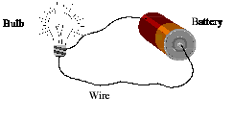

After making the first circuit, students need to draw the circuit they have made and label the components. Then, they will write their observations and things they learned.

Next, have the students make a written prediction as to what will happen when another battery is included in the circuit. Then they may make the circuit, draw it, label it and write their observations.

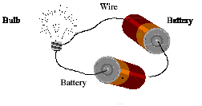

Then have the students make a written prediction about what will happen when another light bulb is included in the circuit, as well as two light bulbs and two batteries. Then they will make the circuit, draw it, label it and write their observations.

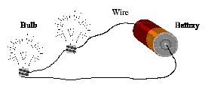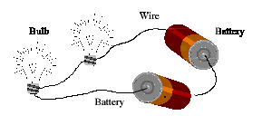

Closure/Conclusion:

After each group has had 30 minutes to make circuits, draw pictures, and write their observations and predictions, pull the group together and discuss their findings. Discuss what they learned and what happened when they added more batteries. Then lead a discussion about how simple circuits are used in our homes, and the importance of complete circuits and power sources.

Assessment:

Students will be assessed on their drawings, predictions and observations.

Script for Electric Circuit Lesson Plan (5th grade)

* Introduce yourself to the class.
  + Most 5th grade classes learn about electricity, so coordinate with the teacher to ensure this lesson comes after they have been taught about electricity and how it works.
* Explain who you are and that you build homes. One really important thing in home building is electricity, to build the house and to be used by the home owners once it is complete. It is nice to be able to cut with a power saw instead of by hand, to flip a switch and have the lights come on in your bedroom, and it is very important for the freezer to be plugged in so you have cold ice cream! As a home builder it is important to understand what a circuit is and how it works, and how the electricity in your home works.
* Explain that you must have certain components in a circuit to have it work. Draw a circuit on the board explaining each of the following components: power source (battery or the utility company) current, switch and load.
* Explain the difference between a complete circuit and an incomplete circuit. The students should already have a good idea about what these words mean.
* After you have explained the model to the students, have the students create their own circuits. Tell the students that they are going to be required to build at least two different circuits. The first will only use one battery and the other will use two batteries. They will be required to make predictions about what they think will happen with the circuit, draw each circuit, label the parts and after making the circuit, and write conclusions about what happened. Write on the board this list of to do’s to help them stay on task.

To Do:

* Predict what will happen (write it down).
* Make the model.
* Draw the model and label the parts.
* Write a conclusion about what happened.
* Split the students in to groups of two to five depending upon teacher recommendations. Give the students the materials they will need and a piece of paper.
* As the students are working and making models, wander around and help answer questions, as well as remind them to write their predictions before they make the model. Remind them that they need to label the model and write a conclusion about what happened after they make each model.
* After the students have had the allotted time to make their models, predictions and conclusions, pull the class back together. Gather all of the materials and then lead a discussion of what they learned. Talk about your experience with electricity in homes where a circuit becomes incomplete and no longer works. You can also talk about how things have changed with two batteries vs. one (too many points on a circuit). Ask what they think will happen if you used more batteries. Explain the difference between the batteries they used and the electricity that runs through their homes.

The teacher may want to collect their drawings for grading purposes.