SUICIDE PREVENTION TOOLBOX TALK – TOPIC 1
ADDRESSING SUICIDE AND MENTAL HEALTH IN CONSTRUCTION
TOPIC OF THE DAY – THE STATE OF OUR INDUSTRY

How big is the suicide problem?
- Suicide is the 10th leading cause of death in the US and it’s getting worse.
- Nearly 45,000 suicides in the US in 2016 (more than deaths from motor vehicle crashes).
- Males account for almost 4 out of 5 suicide deaths.
- Construction has 2nd highest rate of suicides among all occupations, 4 times higher than in the general population.

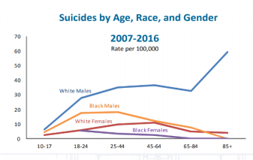

Why the construction industry?
- Male dominated industry with a macho culture
- High job stress – demanding schedules, seasonal work, layoffs, long hours, frequent travel
- Injuries and chronic pain; sometimes treated with opioids
- High rates of alcohol and drug use

So what do we do?
- Talk about it! Make it part of the safety conversation.
- Learn to recognize the warning signs in yourself and others.
- Seek help from national and local resources.

SUICIDE PREVENTION TOOLBOX TALK – TOPIC 2
ADDRESSING SUICIDE AND MENTAL HEALTH IN CONSTRUCTION
TOPIC OF THE DAY – REDUCE THE STIGMA

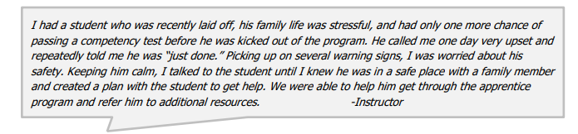
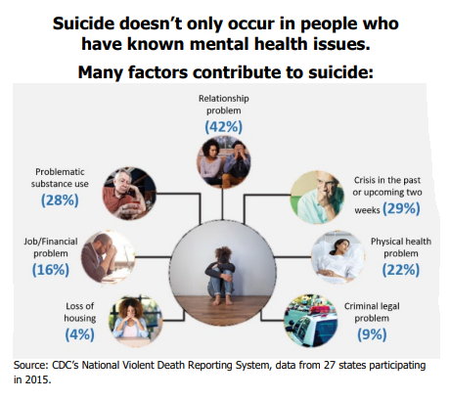
Risk Factors in the Construction Industry
- Stoic, “tough guy” culture
- Seasonal unsteady employment
- Travel away from home
- High pressure to produce on time
- Physically demanding work & chronic pain
- Industry with highest rate of prescription opioids & second highest rate of heavy alcohol use
- Sleep disruption
- Culture of substance abuse
- Fearlessness & risk-taking
- Access to lethal means (firearms & jobsite hazards)

SUICIDE PREVENTION TOOLBOX TALK – TOPIC 3
ADDRESSING SUICIDE AND MENTAL HEALTH IN CONSTRUCTION
TOPIC OF THE DAY – RECOGNIZING THE WARNING SIGNS

Mental health is a personal issue, a family issue, a work issue, and a society issue. This is why mental health should be part of the safety conversation.

It’s not always obvious when a friend of coworker is struggling, but they often show signs of suicidal thoughts in subtle ways. While some comments or threats could sound like “just talk,” they can become dangerous quickly and it’s important to step in or speak up if you see these warning signs.

Warning Sign | You may see or hear your coworker…
Anxiety or agitation | Appear nervous, shaken or worried.
Aggressive behavior or uncontrolled anger | Act overly bitter, hostile, or seek revenge. May engage in violence by getting into fights or punching holes in walls.
Withdrawal | Stop talking to friends or doing things they used to enjoy.
Feel like a burden | Mention feeling like they have let down their coworkers or family; feel worthless.
Reckless behavior | Work dangerously and does not seen to care about the consequences.
Changes in habits | Complain of changes in sleep or show significant weight gain or loss.
Depression | Mention feeling very sad or withdrawn and lasing for more than two weeks.
Increased alcohol or drug use | Begin using alcohol or drugs more than usual.

Signs of Imminent Danger
Feeling desperate | Mention they don’t see their situation changing or a way out; feeling trapped.
Tying up loose ends | Give away favorite tools or possessions or putting affairs in order.
Saying goodbye | Say a final goodbye (subtle or literal) to coworkers, friends, and/or family
Sudden mood changes | Display sudden overwhelming fear or their mood shifts from despair to calm.
Talking about suicide or wanting to die | Make statements that are subtle, vague, or direct. Could be written or drawn.
Seeking access | Start looking around to get the tools they need to complete the act of suicide, such as a gun, prescription, or other means.

If any of the signs above are present:
- Bring it to the attention of your foreman or supervisor.
- Start the conversation with your coworker about your concerns and refer them to or help contact the National Suicide Prevention Lifeline or the Crisis Text Line.

If you believe a coworker is in imminent danger or has already harmed himself or herself, you need to call emergency services at 911.

SUICIDE PREVENTION TOOLBOX TALK – TOPIC 4
ADDRESSING SUICIDE AND MENTAL HEALTH IN CONSTRUCTION
TOPIC OF THE DAY – STARTING THE CONVERSATION

It is not always easy to talk to someone about suicide/mental health, but when someone's life is at risk, it is more important to ensure their safety than dance around the topic.
Here is a step-by-step guide to help you through the conversation.
- ASK – Start the Conversation
  - Prepare: Practice what you will say, plan for a time when you won’t be rushed, and come with crisis resources on hand. It’s important to be patient, understanding, and provide hope.
  - Using non-judgmental language, ask directly about suicide. Mention what prompted you to ask, making it clear you aren’t asking “out of the blue.” If they answer YES to your direct question about suicide, stay calm and don’t leave the person alone until further help is obtained.
- BE THERE - Listen, Express Concern, Reassure
  - Listen your coworker and validate their feelings, let the person know you are genuinely concerned, and that you take their situation seriously.
- KEEP THEM SAFE - Create a Safety Plan
  - Create a safety plan together. Ask what will help keep them safe and make sure they do not have access to any lethal means and ask if they will refrain from using drugs or alcohol.
  - Get a verbal commitment that the person will not act upon thoughts of suicide until they have met with a professional.
- HELP THEM CONNECT - Get Help
  - Provide the resources you have come prepared with.
  - Give them a “warm hand off” to someone who can help. Help them call the National Suicide Prevention Lifeline or connect them with a mental health professional. Stay connected
  - If you feel the situation is critical, take the person to a nearby Emergency Room or call 911.
- What NOT to say
  - Don't ask about suicide in a way that indicates you want "No" for an answer.
  - Don't tell the person to do it. This is the most dangerous thing you can say.
  - Don't promise secrecy. Instead, you can say: "I care about you too much to keep a secret like this. You need help and I am here to help you get it."

REMEMBER: Talking about suicide does NOT put the idea in someone’s head. It gives them permission to talk about it & they are usually relieved.

SUICIDE PREVENTION TOOLBOX TALK – TOPIC 5
ADDRESSING SUICIDE AND MENTAL HEALTH IN CONSTRUCTION
TOPIC OF THE DAY – RECAP

Key Takeaways from this Week:
Suicide is a serious problem in the construction industry. Construction has the 2nd highest rate of suicides among all. It is a high stress job that has high rates of alcohol and drug use, as well as a “tough guy” culture.
Suicide doesn’t only occur in people who have known mental health issues. Even though there are many contributing factors, the problem with suicide is the stigma associated with mental health. Mental health is a personal issue and a work issue. It needs to be a part of the safety conversation.
Recognize the warning signs. If you notice a coworker exhibiting any warning signs, such as comments of hopelessness or reckless behavior, step in or speak up. Some behaviors, such as saying good-bye and giving away belongings, require immediate action and may require you to call 911.
When someone is at risk, it’s important to start a conversation. Ask directly about the issue, listen to them, and create a safety plan together. Don’t be afraid to seek outside help from a suicide hotline or supervisor.

- Look out for your fellow coworkers and recognize that suicide is a serious issue.
- Don’t be afraid to speak up and seek help.
- REMEMBER – Talking about suicide does not put the idea in someone’s head. It can provide relief and gives them permission to talk about it.

