Marble Roller Coaster Activity
Materials:
Per group - 3 sections of 6-ft long pipe insulation (insulation should be cut in half and groups receive 3 half sections)
1 roll of masking tape
1 marble
1 stopwatch

Vocabulary:
Force – A push or a pull that acts on an object
Energy – The ability to do work
Potential Energy – The position of an object above the Earth’s surface.
Kinetic Energy – The energy of motion
Centrifugal Force – The effect that tends to move an object away from the center of a circle it is rotating about
Friction – The resistance force that one surface or object encounters when moving over another.

Activity
Use the materials provided to create the roller coaster according to the plans and specifications provided.
Record data (times) in the table.

Trial | Time in Seconds
1
2
3
4
5
Total time

Average Time = Total Time ÷ Number of Trials

Average Speed = Distance ÷ Time
(Track Length ÷ Average Time)

What was the average time it took for the marble to reach the end of the roller coaster?

What was the average speed of the marble?

Where on the roller coaster does the marble have a centrifugal force acting on it?

At which point did the marble have the most potential energy?

Where did the marble have the most kinetic energy?

What force caused the marble to slow down?
Roller Coaster Plans

Plan View (View from Top)
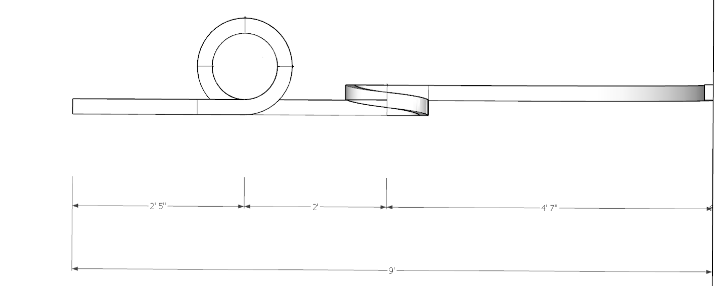
Left Elevation (Left side view) Right Elevation (Right side view)
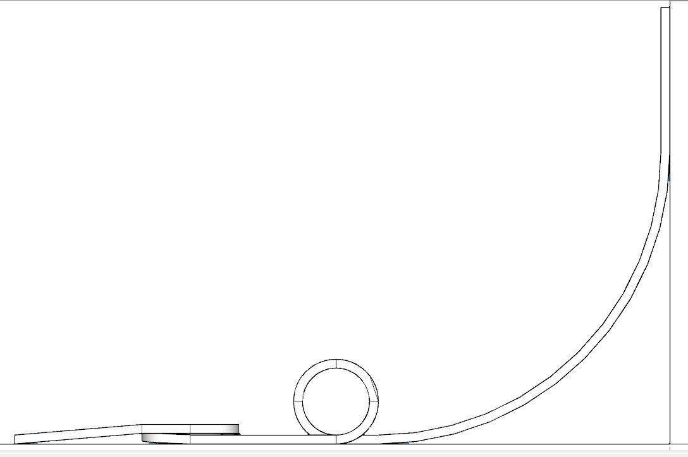
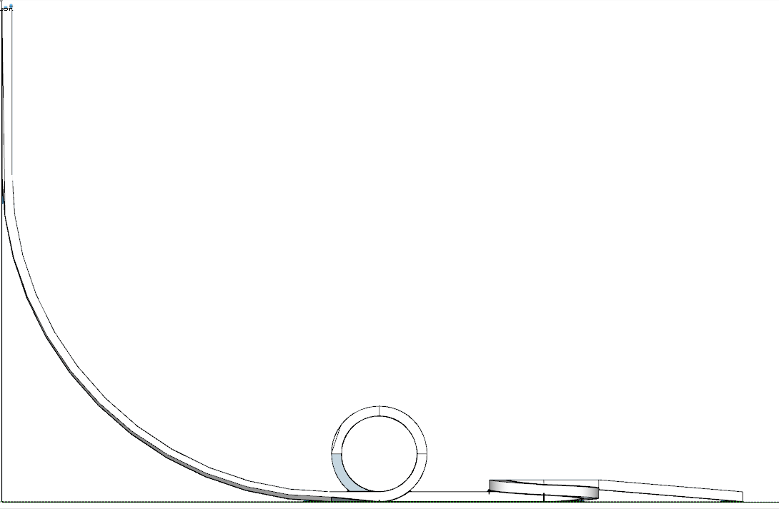

Isometric View
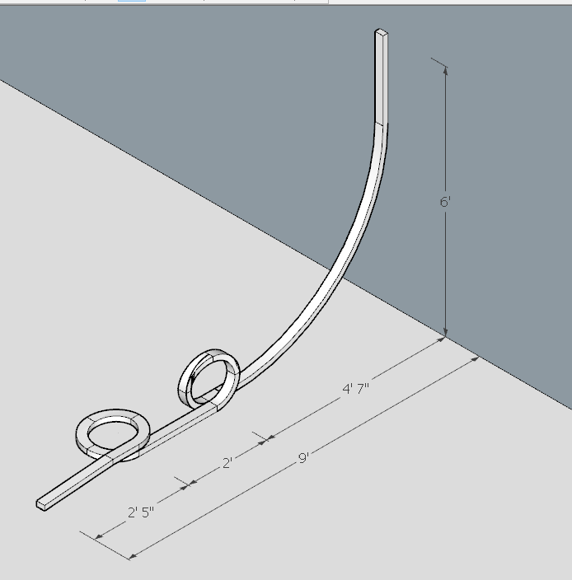
Specifications:
- Roller Coaster should begin at a height of 6'-0" above the ground.
- Roller coaster makes first contact with ground 4'-0" away from the wall.
- Vertical loop has an outside diameter of 16”.
- Center of the vertical loop is 4’7” from the wall.
- Vertical loop starts on the right side and ends on the left (with respect to the direction the marble will travel).
- Horizontal loop begins at 6'7" from the wall.
- Horizontal loop should start by going under itself, and end coming out on top.
- Roller Coaster should end 9'-0" from the wall where it started.

